# Task 3: SQL

I had to run my first execution. To get all my RDBMS I will need to run further queries.

Here is a depicted image of the executed result after my Database (DB) was imported

I had some errors in the tab below because I was entering the wrong query and the executions came up wrong.

I followed the step-by-step guide for each image depicted. To begin, I had to type the USE command to make sure the DB will run the command from the sql_store DB.

I ran a query to multiply the points by 10.

I have created a new column called discount_factor by adding (as discount_factor) to my query and executed it.

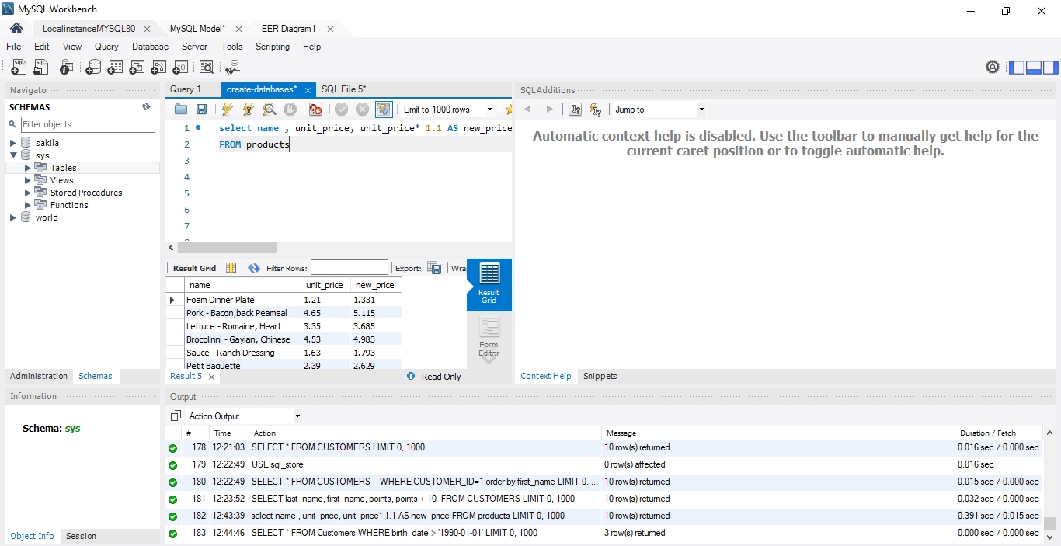

Here I have also created some new columns as the names in the query executed.

I executed the query with customers who have a birth date above 1990.

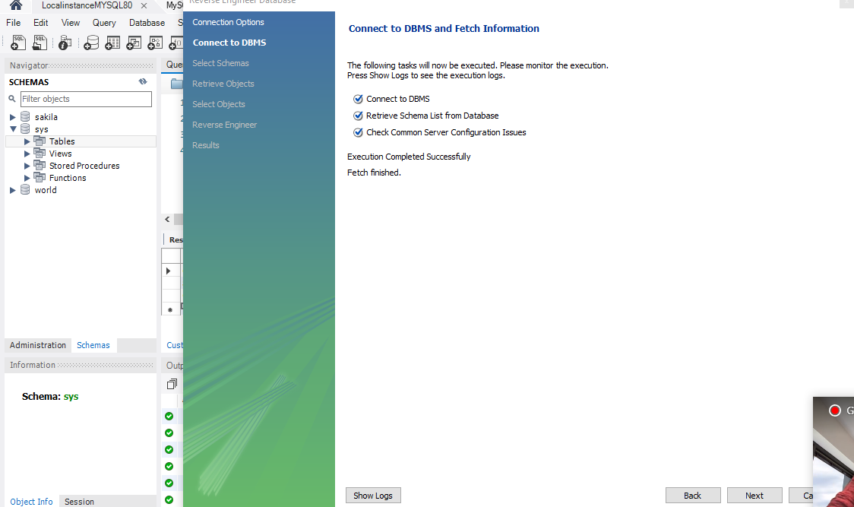

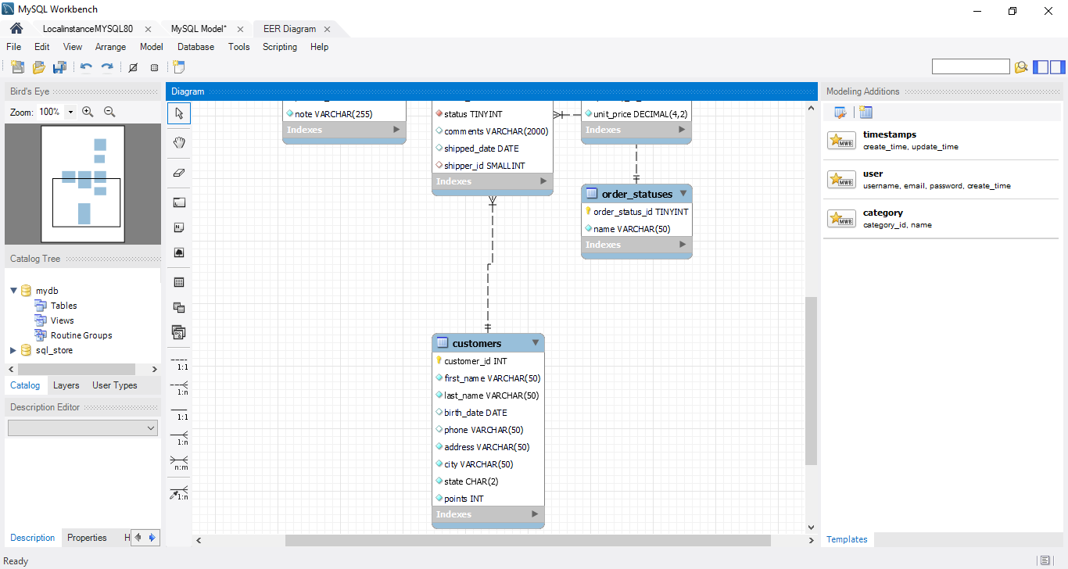

These were my result on EER. This was fun to create. Will do some practice on my own to get better.